Anthony Chavez

Professor Sun

Socket Programming Lab

UDP

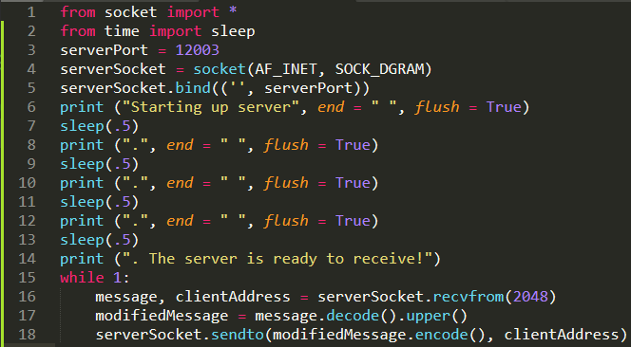

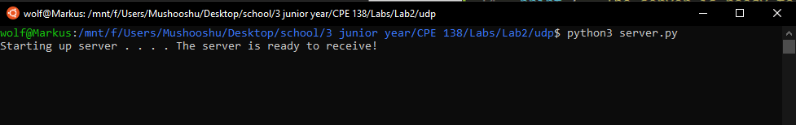The first above snippet is the UDP server code. Just to make the program more interesting, I added a few delays in between some print statements to give the feeling of the program loading. In the second snippet, we can see the output of the UDP server code.

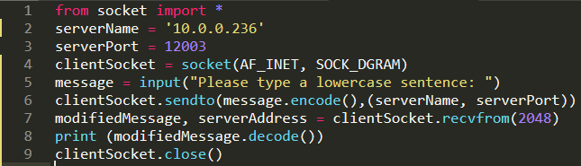

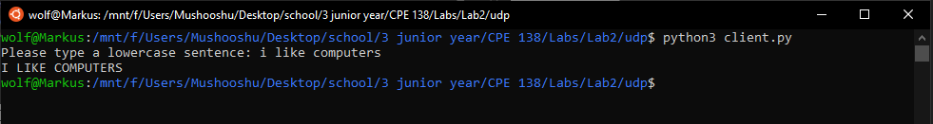

The first above snippet is the client code. This program takes a lowercase sentence from the user and sends the message to the UDP server program shown earlier. The Server will convert the letters in the message to uppercase letters and send the modified message back to this client program where it will be outputted to the screen. We can see the modified message in the second snippet above

TCP

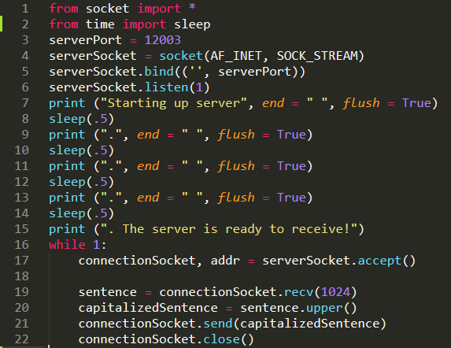

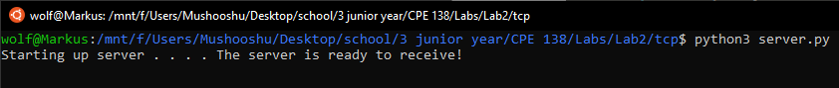

The first above snippet is the TCP server code. Like the UDP server code, I added a few delays in between some print statements to give the feeling of the program loading. In the second snippet, we can see the output of the server code.

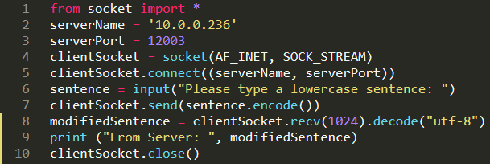

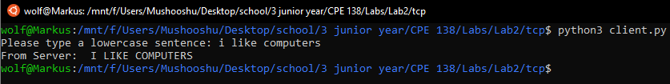

The first above snippet is the TCP client code. Just like the UDP program, the TCP program will send a message containing lowercase letters and the TCP server program will convert all the letters in the message to uppercase letters. Then the TCP server program will send the modified message back to the TCP client program to be outputted to the screen. See the second snippet above for the output.

Appendix: Helpful Sources Used

<https://stackoverflow.com/questions/40164815/why-does-the-print-function-stop-working-with-sleep-with-the-end-argument>

<https://stackoverflow.com/questions/35168508/raw-input-is-not-defined>

<https://www.programiz.com/python-programming/methods/string/encode>